# Introduction

\section{Introduction}

The history of one-handed typing is closely tied to the design of keyboard layouts. The QWERTY keyboard we are familiar with and the oldest was designed with one-handed typing in mind. In the QWERTY layout, more English words can be spelled using only the left hand than using only the right hand. Specifically, more than 3,000 English words can be typed with only the left hand, while only more than 300 words can be typed with only the right hand. The three most common letters in English, 'E', 'T', and 'A', can all be typed with the left hand. \cite{wiki1} While this is detrimental to right-handed people, it also lends credence to the effectiveness of one-handed typing. In 1936, Dvorak improved the QWERTY keyboard and created the Dvorak Keyboard (also called American Simplified Keyboard, or simply Simplified Keyboard), and Dvorak was specially designed for the efficiency of one-handed typing. \cite{dvorak} In 1960, Dvorak designed separate left- and right-handed Dvorak layouts for one-handed typing. The two keyboards are generally mirror images of each other, except for some differences in some uncommon keys, which are suitable for Left-handed people and right-handed people. In the design, he tried to minimize the need to move the hand from side to side (lateral movement), as well as reduce the movement of the fingers. In the past twenty years, there has been new development in the keyboard for one-handed typing. Edgar Matias et al \cite{Matias}invented the Mirrored Keyboard. The idea is to only use one hand (preferably the left one) and type the right-hand letters by holding a key which acts as a modifier key. The layout is mirrored, so the use of the muscle memory of the other hand is possible , which greatly reduces the amount of time needed to learn the layout, if the person previously used both hands to type. This represents people's continuous pursuit of the combination of ergonomics and typing efficiency.

After entering the 21st century, the rapid development of informatization and the increasingly popular electronic products have enabled people to use virtual keyboards on mobile devices in more scenarios than traditional physical keyboards.\cite{Xinhui} As mobile devices are more integrated into people's life scenes, people can not only sit at a computer desk and type on a heavy keyboard, but can also conveniently type in coffee shops, classrooms, or on the bus. Send messages from your mobile device. In different situations, people often free up the other hand to do other things and use only one hand to conveniently complete the typing action. This makes the demand for one-handed typing greatly increased in today's era. \cite{Nicolau} After preliminary research, we found that in addition to the keyboard layout design that may affect the one-handed typing experience, different functions of the keyboard (such as the autocomplete text function) and virtual key sizes, operating systems, etc. will also have an impact on users. One-handed typing efficiency has an impact. Based on these factors, our goal is to discover the difficulties that one-handed typing may encounter in order to better improve the user experience of typing with one hand on mobile devices. In Section (3) we design a questionnaire and conduct a detailed survey of our potential respondents.

\section{Related Work}

One-handed textual entry on mobile phones has been studied extensively by HCI researchers. This area of study is driven by a wide variety of use cases, ranging from improving typing accessibility for those with disabilities to the increasing prevalence of texting while walking. We carry mobile phones around with us all the time, and as a result, interacting with it while on-the-go has become a daily routine \cite{clawson}. According to a recent study in 2022, 26\% of people always use a mobile phone while walking on the street, 43\% sometimes do, 28\% occasionally do, and only 3\% do not \cite{Frej}. While texting on-the-go, individuals must multi-task. They must not only maintain awareness of their surroundings but also be focused on interacting with the mobile device that is in motion. As a result, the combination of multitasking and interacting with a often shaken device, impairs the user’s typing performance and accuracy significantly \cite{clawson}.

# General Questions

* Where to put discussion/conclusion sections in the Overleaf Template?
  + Put them in 10 and 11 respectively
  + Discussion now should only be on assignment 1 (survey results)
* How to insert pdf into overleaf?
  + use other packages
  + do not need to insert it directly into overleaf, can simply indicate appendix (title) in overleaf and then combine pdfs using acrobat
* Is the excel sheet of data ok?
  + yes
* How many references should we have for introduction & related work section?
  + Introduction can be more broad (use more general citations), but need to focus on the 4 things: Promise, Obstacle, Solution, Takeaways.
  + Related work must be more specific and MUST related to the focus of our survey!
    - e.g. Why did we come up with the focus of one-handed text entries
    - e.g. What have people tried on existing one-handed text entries on mobile
  + Number of citations can range from 10 to 20
  + The most important thing is that CITATIONS MUST BE RELATED TO our survey focus!
* What tense should we use for the paper?
* What type of citation or paper style should we use?
  + <https://www.overleaf.com/learn/latex/Bibliography_management_with_bibtex>
  + use bib file downloaded from e.g. google scholar
* Do we submit the report with empty sections?
  + We can just leave them there

Promise: Pick a specific focus within the area of text entry, in particular, within the area of one-handed text entry on mobile devices.

Obstacle: We lack knowledge about one-handed text entry on mobile devices, specifically, whether this is still a problem in the modern day since a lot of studies have been done on this topic.

Solution: Run a survey to find out more about the focus

Takeaways: One-handed text entry still appears to be problematic in the modern day and there may be specific areas for improvement regarding this topic.

Related work

* maybe say that all of them focus on completely redesigning the entire keyboard, we can try to only modify certain parts of the keyboard to make it more usable
  + they didn’t really say what is the specific problems of each keyboard

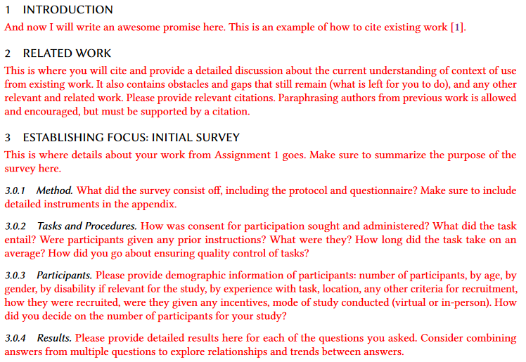

Focus: Keyboard text entry on smartphone with one hand.

# Participants

The inclusion and exclusion criteria for participants was intentionally lenient, since this was only the initial stage of user-centered design and we aimed to understand the context of use for as many stakeholders as possible. Thus, we defined the protocol to include all participants over the age of 18 *and* have previously *used* a smartphone, and exclude those otherwise.

A convenient sample was selected using a snowball method. Each team member sent out the final survey online as an URL link to all of their acquaintances who met the participants’ inclusion criteria defined in the survey protocol. Those who received the survey were informed to complete it virtually at their convenience and then forward it to 2 or 3 acquaintances who may be potential stakeholders. No monetary incentives were given for the completion of the survey. Using the snowball method, we hoped to gather *as many responses as possible*. After three days of data collection, a total of 27 participants completed the survey (96.3% between ages 18-25; 77.8% Asian, 11.1% White and Asian, 11.1% other; 66.7% Man; 55.6% unemployed; 71.8% multilingual; 3.7% have a disability; see Table 1-6 for complete demographics breakdown). The data is completely anonymous and no personal information was collected from the participants.

Table 1. Age group of participants

| **Age group** | **Number of participants** |
| --- | --- |
| 18-25 | 26 |
| 26-40 | 1 |
| 41-60 | 0 |
| 61-80 | 0 |
| 80+ | 0 |

96.3% between ages 18-25, 3.7% between ages 26-40

Table 2. Race and ethnicity of participants

| **Race and ethnicity** | **Number of participants** |
| --- | --- |
| White | 0 |
| Latinx or Latin American | 0 |
| Black or African American | 0 |
| American Indian or Alaska Native | 0 |
| Asian | 21 |
| South Asian | 1 |
| Middle Eastern or North African | 0 |
| Native Hawaiian or Pacific Islander | 0 |
| Multiracial (specifically, White and Asian) | 3 |
| Prefer not to answer | 2 |
| Other | 0 |

77.8% Asian, 11.1% White and Asian, 3.7% South Asian, 7.4% prefer not to say

Table 3. Gender identity of participants

| **Gender identity** | **Number of participants** |
| --- | --- |
| Woman | 7 |
| Man | 18 |
| Non-binary / Gender fluid | 1 |
| Indigenous or other cultural minority gender (e.g., two-spirit) | 0 |
| Prefer not to answer | 1 |
| Other | 0 |

66.7% man, 25.9% woman, 3.7% non-binary/gender fluid, 3.7% prefer not to answer

Table 4. Employment status of participants

| **Employment status** | **Number of participants** |
| --- | --- |
| Employed full-time | 9 |
| Employed part-time | 3 |
| Self-employed | 0 |
| Unemployed (including student) | 15 |
| Retired | 0 |
| Other | 0 |

55.6% unemployed (including student), 33.3% employed full-time, 11.1% employed part-time

Table 5. Language proficiency of participants

| **Number of languages proficient** | **Number of participants** |
| --- | --- |
| 1 | 6 |
| 2 | 15 |
| 3 | 6 |
| 4+ | 0 |

55.6% proficient in 2 languages, 16.2% proficient in 1 language, 16.2% proficient in 3 languages

Table 6. Disability status of participants

| **Disability status** | **Number of participants** |
| --- | --- |
| Yes | 1 |
| No | 24 |
| I don’t know | 2 |
| Prefer not to say | 0 |

88.9% do not have a disability, 7.4% do not know, 3.7% have a disability

# Results

The survey data were exported from Google Form and the corresponding plots were made for each question (other than the demographics questions) using the Chart feature in Google Sheets. The questions and their results are listed in the order which they appeared in the survey. The results of the questions are analyzed either individually, written immediately after a figure, or in a group, written after a contiguous block of figures.

## Questions about General Smartphone Usage

Question 1: On average, how long do you use your smartphone per day?

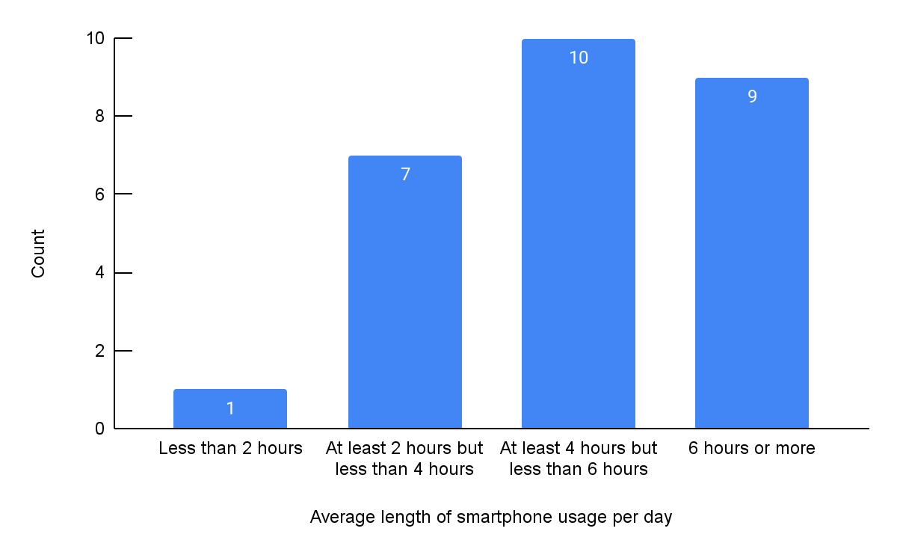

Figure 1. Count of participants’ average lengths of smartphone usage per day.

**Participants are roughly evenly distributed among using their smartphone for at least 2 hours but less than 4 hours (7 out of 27, 25.9%), at least 4 hours but less than 6 hours (10 out of 27, 37.0%), or 6 hours or more (9 out of 27, 33.3%) per day. Only 1 participant (3.7%) uses their phone for less than 2 hours per day.**

Question 2: What brand is your smartphone?

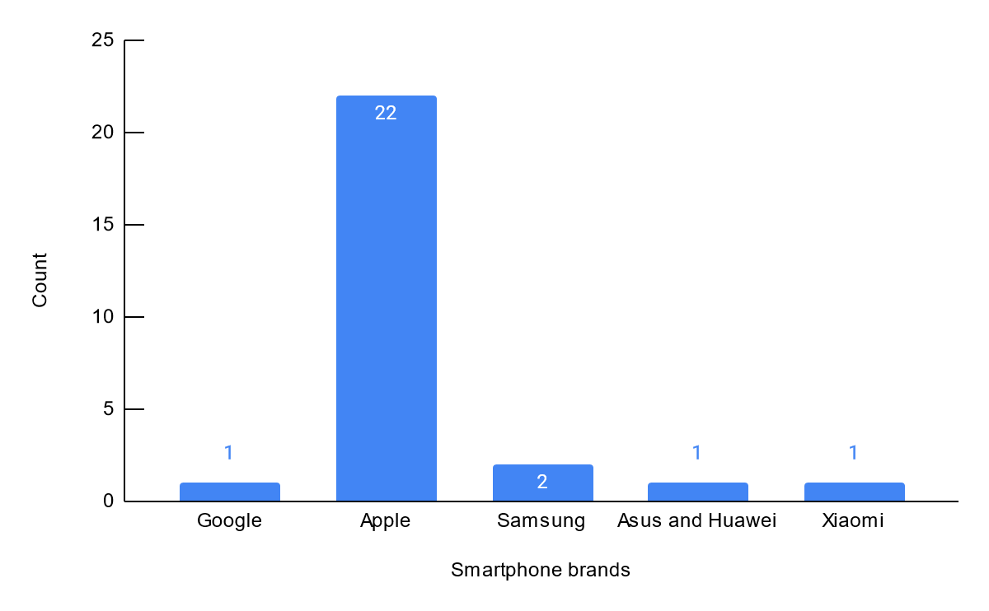

Figure 2. Count of participants’ smartphone brands.

**An overwhelming majority of participants (22 out of 27, 81.5%) have Apple as their smartphone. The remaining participants were roughly evenly distributed among using Google, Samsung, Xiaomi, and Asus/Huawei as their smartphone. This implies that the majority of the participants would be using Apple’s IOS operating system as well as its associated features and are subjected to IOS’s user experience designs.**

Question 3: Have you ever entered text (typed on the virtual keyboard) on your smartphone with one hand?

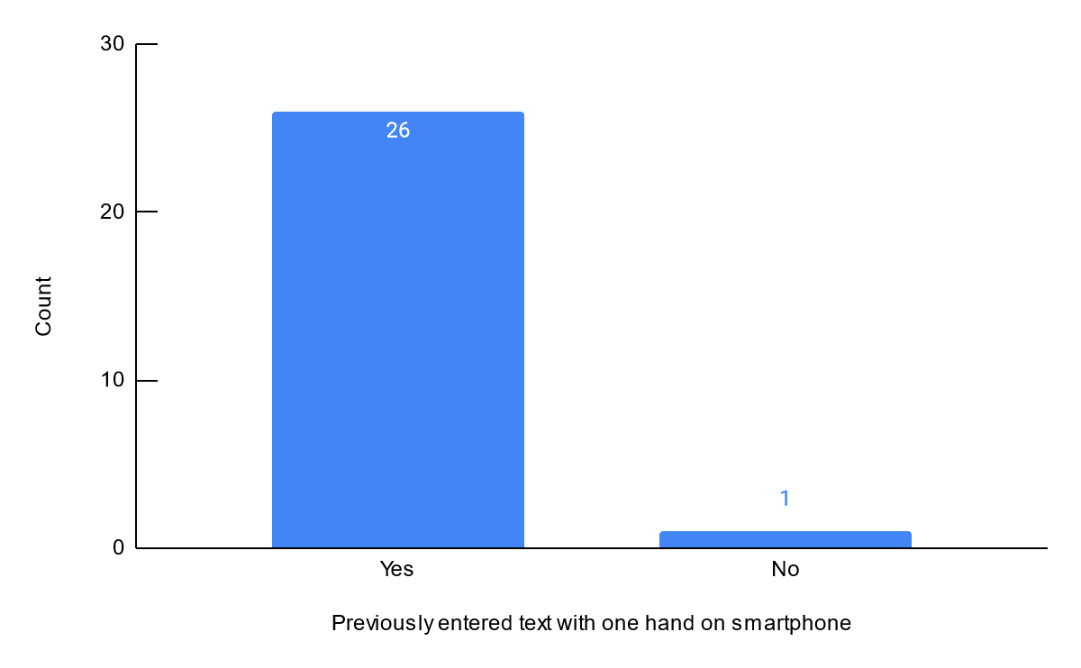

Figure 3. Count of participants who have previously entered text with one hand on a smartphone.

**Almost all participants (26 out of 27, 96.3%) have previously entered text with one hand on a smartphone. The one person who has never entered text with one hand skipped the next section in the survey which contains mainly questions about one-handed text entry.**

## Questions Related to Our Focus of One-Handed Text Entry

Question 4: How often do you enter text on your phone with one hand?

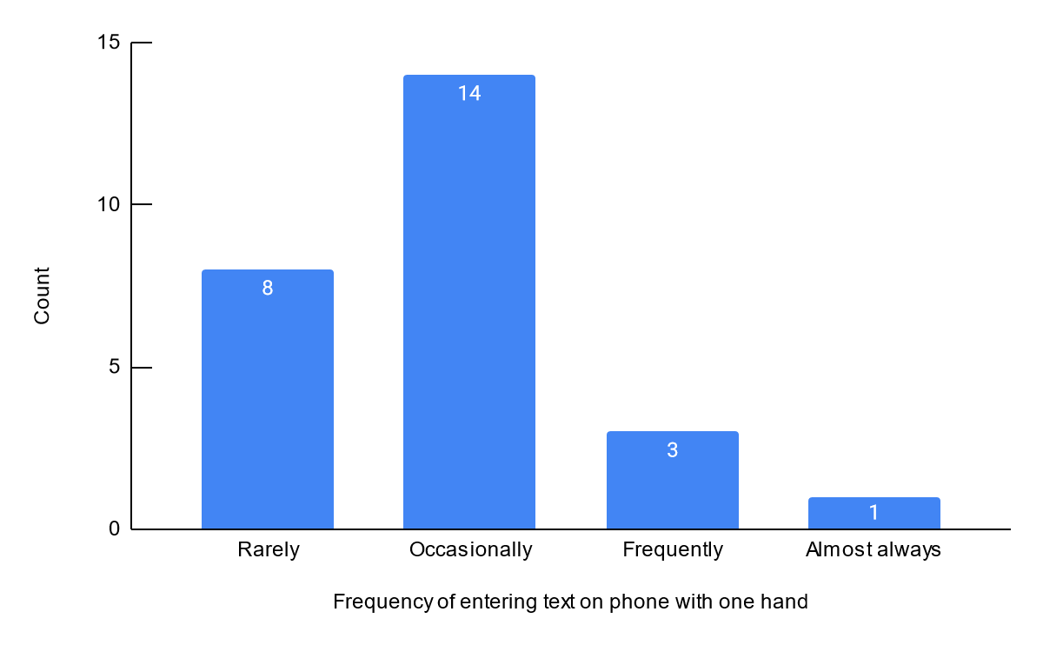

Figure 4. Count of different frequencies of one-handed text entry on a smartphone performed by participants

**Out of the participants who have previously entered text on their smartphone with one hand, a majority of them (14 out of 26, 53.8%) occasionally do so, whereas some of them (8 out of 26, 30.8%) rarely do so. Though these adjectives are not too impactful, the results of this and the previous question still demonstrate the existence of one-handed text entry on smartphones as a valid interaction between the user and the technology.**

Question 5: Do you usually enter text with your phone in a vertical or horizontal position?

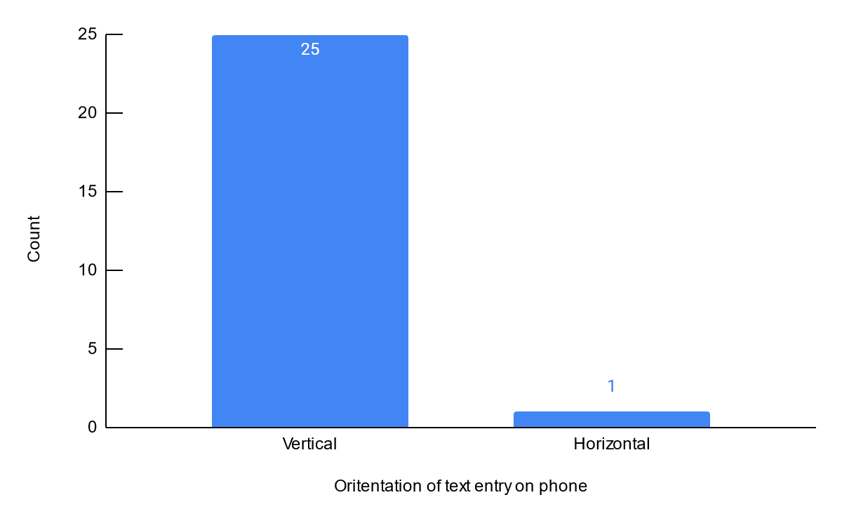

Figure 5. Count of different orientations of text entry on phone used by participants

**Out of the participants who have previously entered text on their smartphone with one hand, almost all of them (25 out of 26, 96.2%) tend to enter text vertically.**

Question 6: How comfortable are you with typing on your phone with one hand?

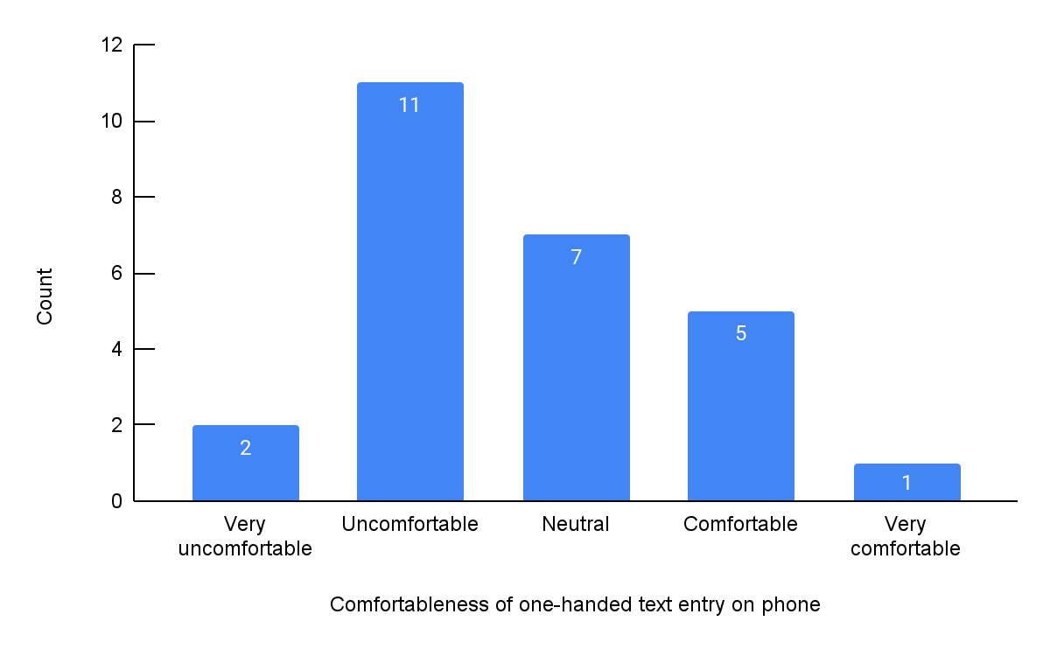

Figure 6. Count of different levels of comfortableness experienced by participants when performing one-handed text entry on phone

Question 7: What is the level of difficulty you find when entering text with one hand compared to entering text with both hands?

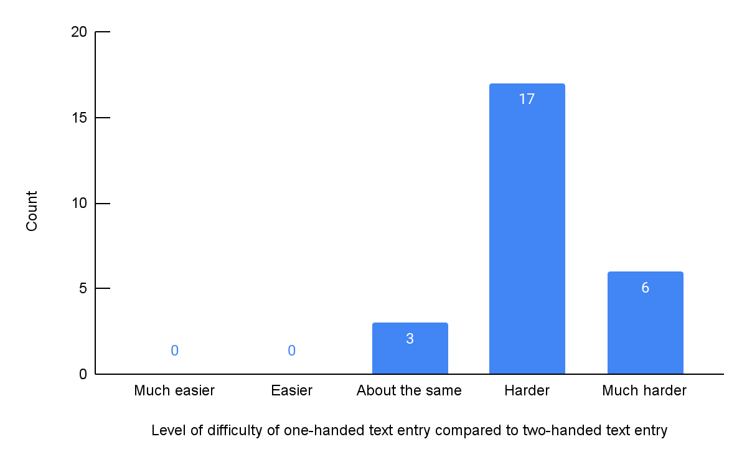

Figure 7. Count of different levels of difficulty experienced by participants when performing one-handed text entry compared to two-handed text entry

Question 8: What is your typing speed when entering text with one hand compared to entering text with both hands?

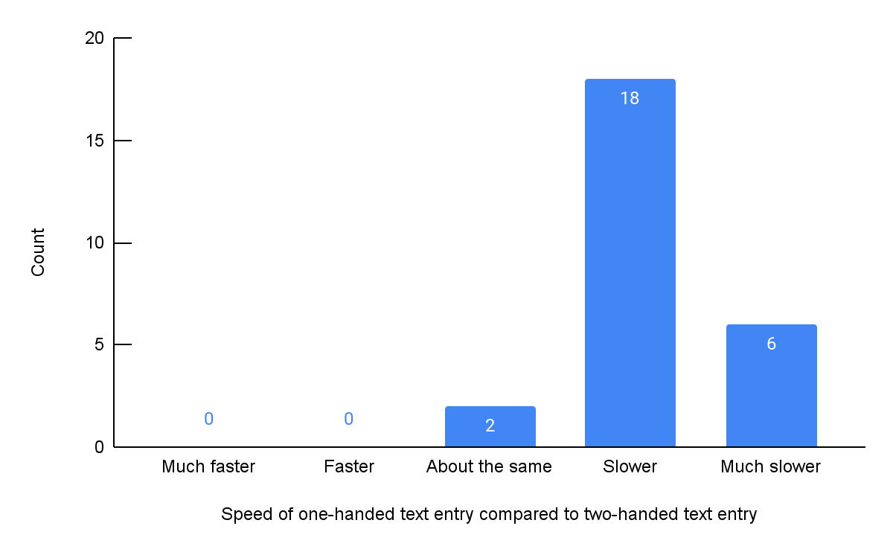

Figure 8. Count of different typing speeds experienced by participants when performing one-handed text entry compared to two-handed text entry

**Questions 6, 7, and 8 attempt to measure the usability of existing smartphones’ keyboards when performing one-handed text entry across three facets: comfortableness, difficulty, and efficiency. As shown in Figure 6, exactly half of participants (13 out of 26) find typing on their phone with one hand to be uncomfortable to very uncomfortable, while the other half of participants either have neutral opinions (7 out of 26, 26.9%) or find it to be comfortable to very comfortable (6 out of 26, 23.1%). Moreover, an overwhelming majority of participants find it *harder* (23 out of 26, 88.5%) and *slower* (24 out of 26, 92.3%) to enter text with one hand compared to entering text with both hands, as shown in Figure 7 and 8, respectively. None of the participants find it *easier* or *faster* to enter text with one hand compared to two hands. This indicates that there are flaws in the current smartphones’ keyboards for one-handed text entries.**

Question 9: How often do you make mistakes/typos when entering text with one hand compared to entering text with both hands?

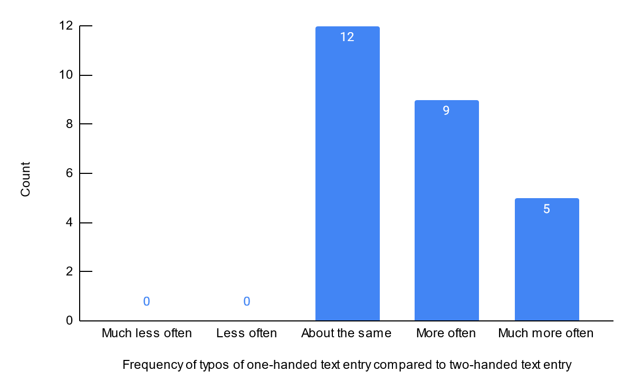

Figure 9. Count of different frequencies of typos experienced by participants when performing one-handed text entry compared to two-handed text entry

Question 10: What is the level of difficulty you find when fixing mistakes/typos with one hand compared to fixing mistakes/typos with both hands?

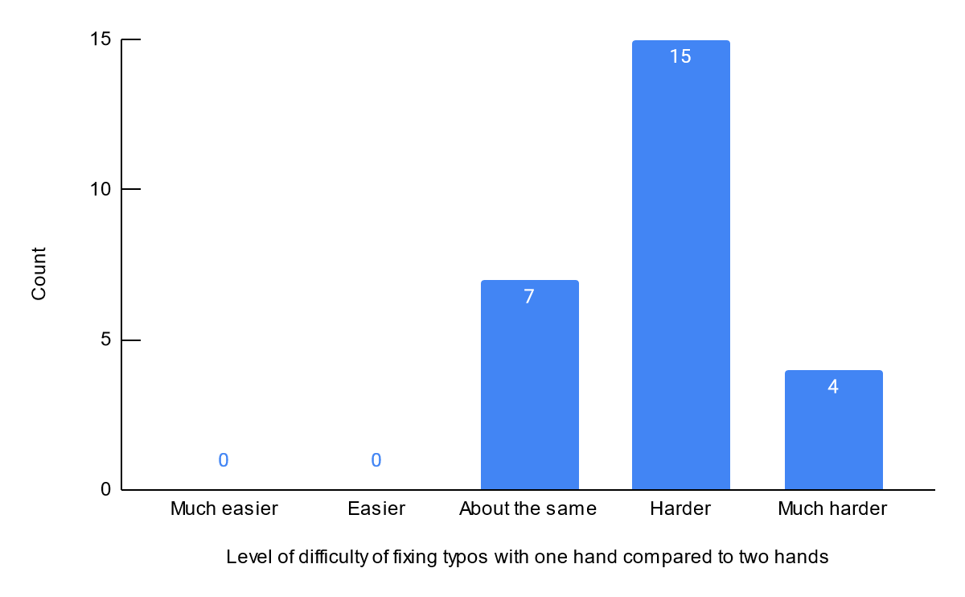

Figure 10. Count of different levels of difficulty experienced by participants when fixing typos with one hand compared to two hands

Question 11: What is your opinion on the autocorrect feature of your phone’s keyboard?

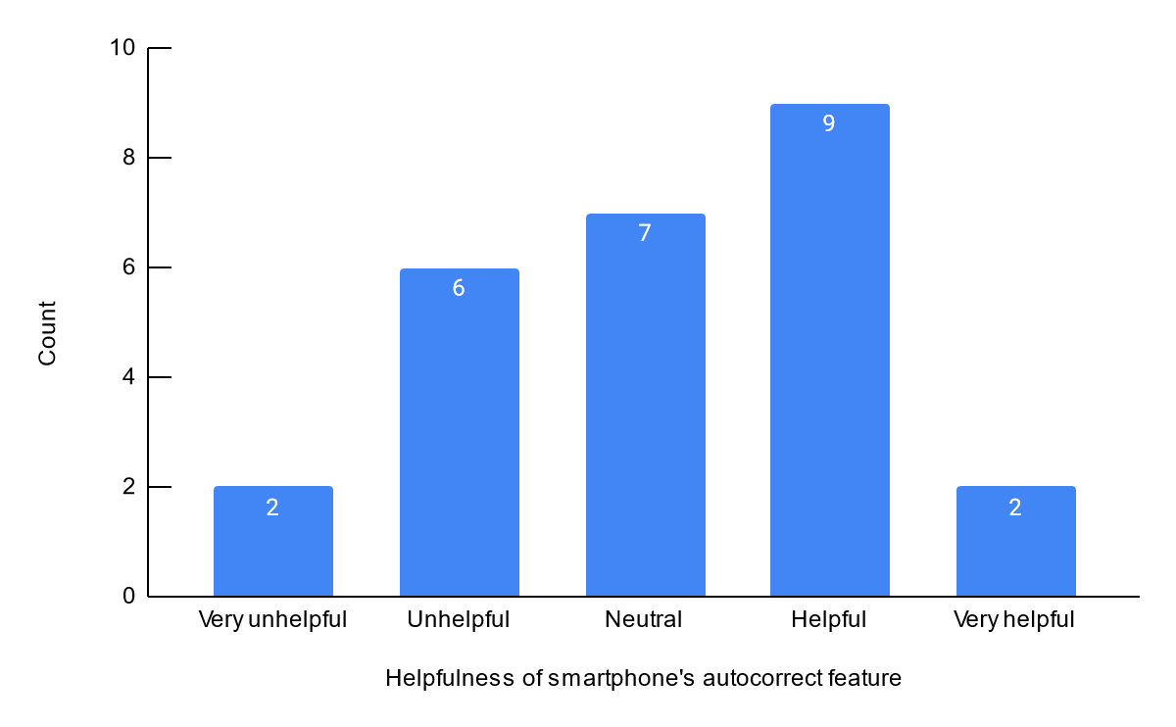

Figure 11. Count of different opinions expressed by participants on the helpfulness of smartphone’s autocorrect feature

**Questions 9, 10 and 11 attempt to further explore the usability of the existing smartphone’s keyboard for one-handed text entry, specifically regarding the ability to avoid and correct mistakes (typos). As shown in Figure 9, the majority of participants (14 out of 26, 53.8%) tend to make typos more often or much more often when entering text with one hand compared to with both hands, and the remaining participants (12 out of 26, 46.2%) make typos with one hand as often as with both hands. Similarly, the vast majority of participants (19 out 26, 73.1%) believe that it is more difficult to correct typos on their phone with one hand than with both hands, while the remaining (7 out of 26, 26.9%) believe that it is about the same level of difficulty, as shown in Figure 10. This indicates that the existing keyboard on a smartphone may be more error-prone and harder to correct mistakes when typing with one hand compared to with both hands.**

**Contrary to the prior two questions’ data with uneven distributions that skew towards the right, regarding the helpfulness of the autocorrect feature, the opinions are roughly evenly split on both sides. As shown in Figure 11, 11 out of 26 participants (42.3%) think that autocorrect is either helpful or very helpful, 8 participants (30.8%) think it is unhelpful or very unhelpful, whereas the remaining 7 participants (26.9%) have neutral opinions about autocorrect. Though there are more participants with positive opinions on the autocorrect feature, it is difficult to conclude anything as this difference is marginal and the sample is quite small. Thus, it is safer to say that there appears to be mixed opinions on the autocorrect feature of a smartphone; additional questions and corresponding statistical analysis may be needed, for instance, to test which aspects of the autocorrect feature people think are helpful and which aspects are not.**

Question 12: On a scale of 1 (easy to use) to 5 (hard to use), what is your opinion on your phone’s keyboard layout when typing single-handed?

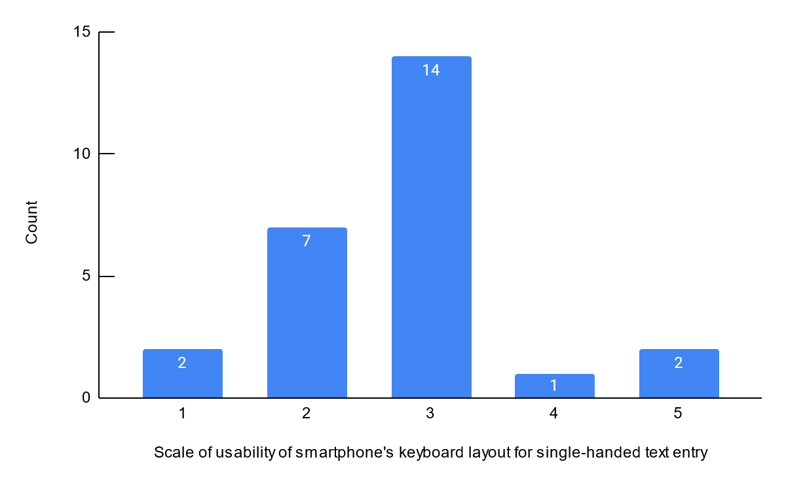

Figure 12. Count of different levels of usability of keyboard layout experienced by participants when performing one-handed text entry

Question 13: What do you think of the size of the keys on your smartphone’s (default) virtual keyboard?

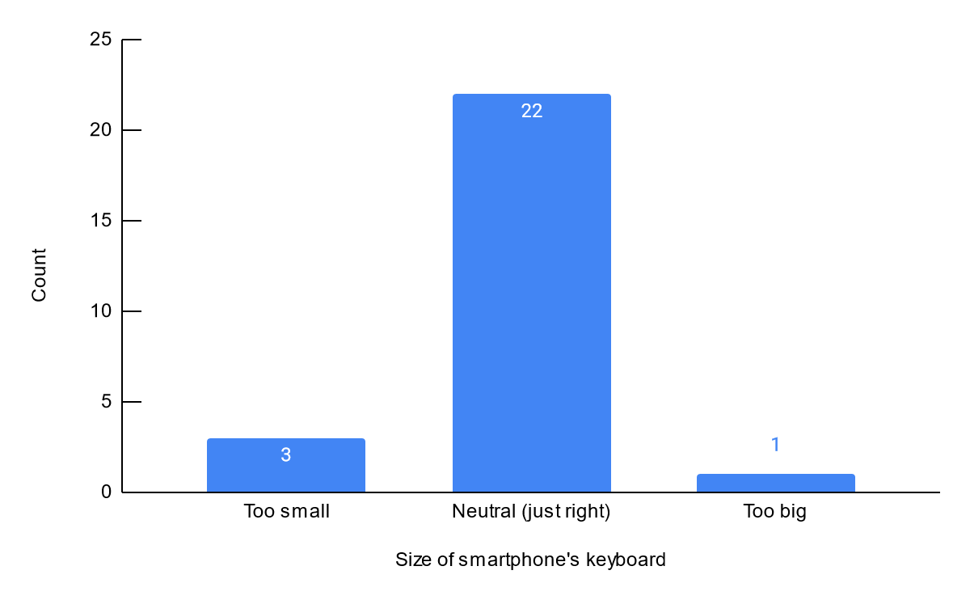

Figure 13. Count of different opinions on the size of the keyboard expressed by participants

**Questions 12 and 13 aim to test whether layout and size play a role in the usability of a smartphone’s keyboard for one-handed text entry. Figure 12 shows that a majority of participants (14 out of 26, 53.8%) have neutral opinions about their current text entry keyboard layout, while the general view is that the data is somewhat skewed towards the ‘easier’ side, with 7 out of 26 (34.6%) participants believing the layout is easy or very easy to use. This indicates that most people are already satisfied with the existing layout of a smartphone’s keyboard. Similarly, almost all participants (22 out of 26, 84.6%) think that the size of keys on their smartphone’s keyboard is just about right as shown in Figure 13. Together, the data of these two questions imply that key size and general layout are likely not major factors that contribute to the difficulty of single-hand text entry on mobile devices. These results are in face of the finding that the participants make mistakes typing text more often one-handed, if not just as often as with both hands.**

Question 14: What is the level of difficulty you find when switching between numbers and letters using one hand compared to that of two hands?

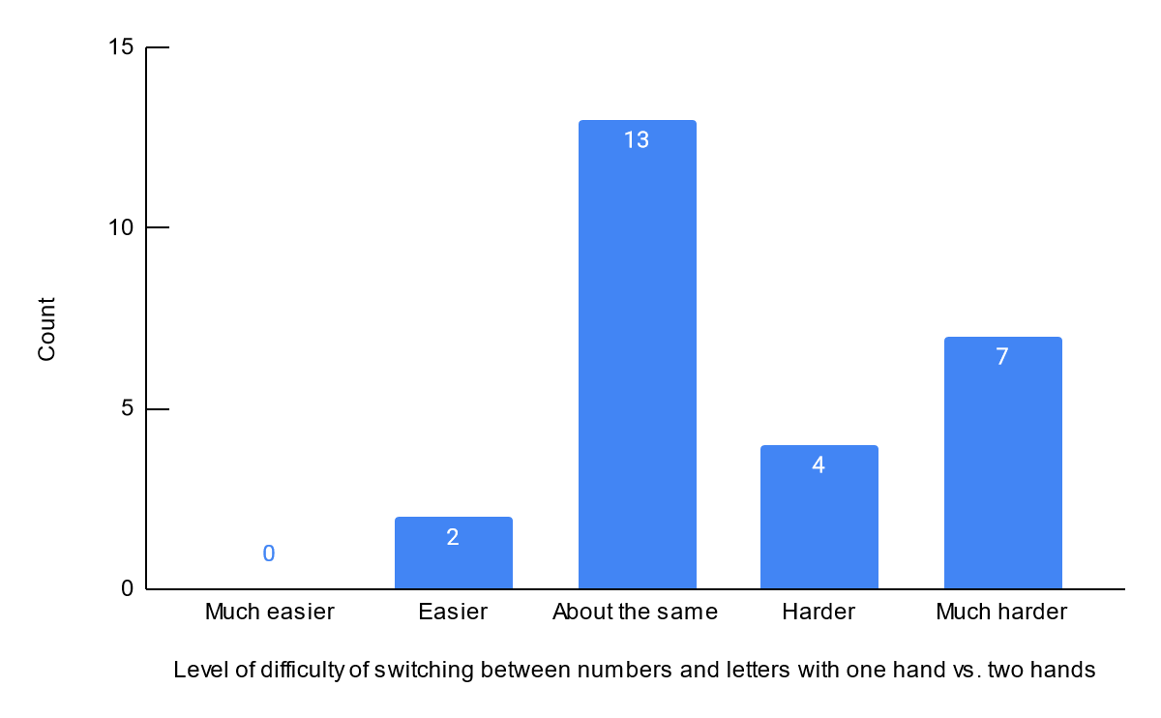

Figure 14. Count of different levels of difficulty experienced by participants when switching between numbers and letters using one hand compared to two hands

Question 15: How often do you switch languages (including emojis) on your keyboard?

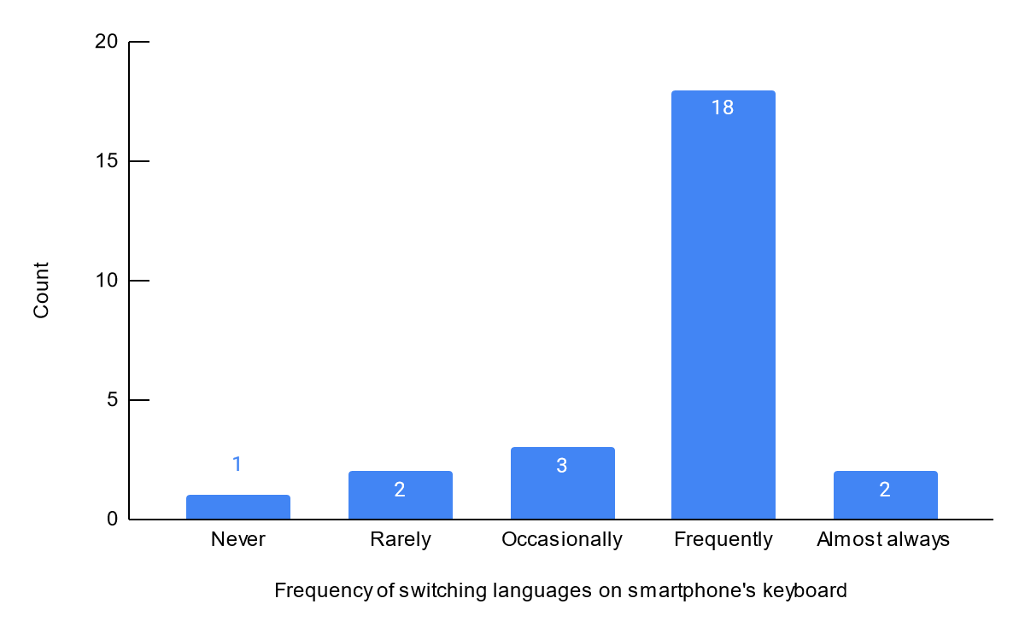

Figure 15. Count of different frequencies of switching keyboard languages experienced by participants

Question 16: What is the level of difficulty you find when switching languages using one hand compared to that of two hands?

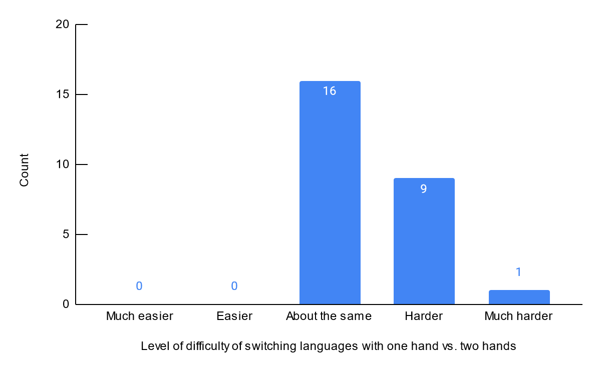

Figure 16. Count of different levels of difficulty experienced participants when switching keyboard languages with one hand compared to two hands

**Questions 14, 15, and 16 aim to test whether keyboard switching plays a role in the usability of a smartphone’s keyboard for one-handed text entry. In Figure 14, 11 out of 26 participants (42.3%) think it is hard or much harder to input text when they need to switch between alphabetic and numeric keyboard with one hand. Although 13 participants (0.5%) have neutral opinions on this topic, compared to keyboard layout and key size, keyboard switching does invoke a relatively more negative feedback pertaining to text entry with one hand.**

**A related finding is about switching between language keyboards. It is a similar operation to switching to the numeric keyboard. As is shown in Figure 15 and 16, a majority of participants switch between different languages frequently and think the difficulty to do so with one hand is about the same as with both hands. Yet from Figure 16, we can also observe that no participant thinks switching with one hand is easy; 10 out of 26 (38.5%) believe it is hard or very hard to perform such a task with just one hand.**

**Together, the results of these 3 questions indicate that switching between numbers and letters, and switching languages could be contributing factors towards difficulty of single-hand text entry.**

Question 17: What is your dominant hand?

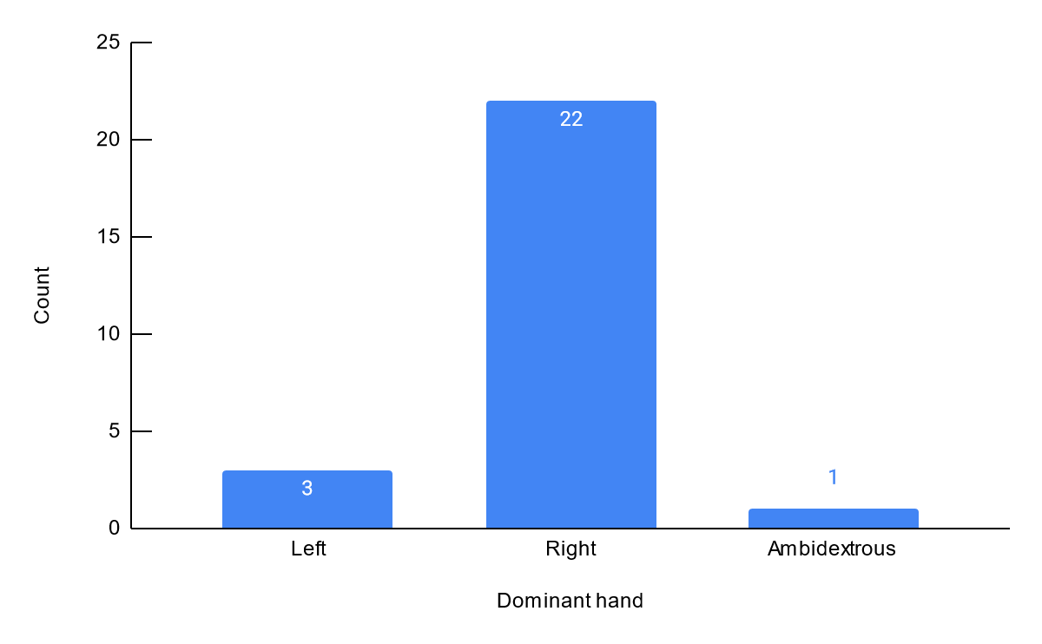

Figure 17. Count of different dominant hands of participants

**Of all 26 participants, 22 (84.6%) have their right hand as the dominant hand, only 3 (11.5%) participants’ dominant hand is their left hand, and 1 (3.8%) participant is ambidextrous. An effective keyboard design for single-handed text entry should take the user's dominant hand into consideration and should take the benefit of the doubt that the design for right-hand may not mirror exactly to the design for left-hand. Thus, it may be better to narrow the focus to text-entry with the right hand, and first design specifically for users whose dominant hand is the right hand. In future iterations on the design, designers may take accessibility into consideration and design for those whose dominant hand is not their right hand.**

## Miscellaneous Questions

Question 18: How comfortable are you typing on your phone without looking at the keyboard?

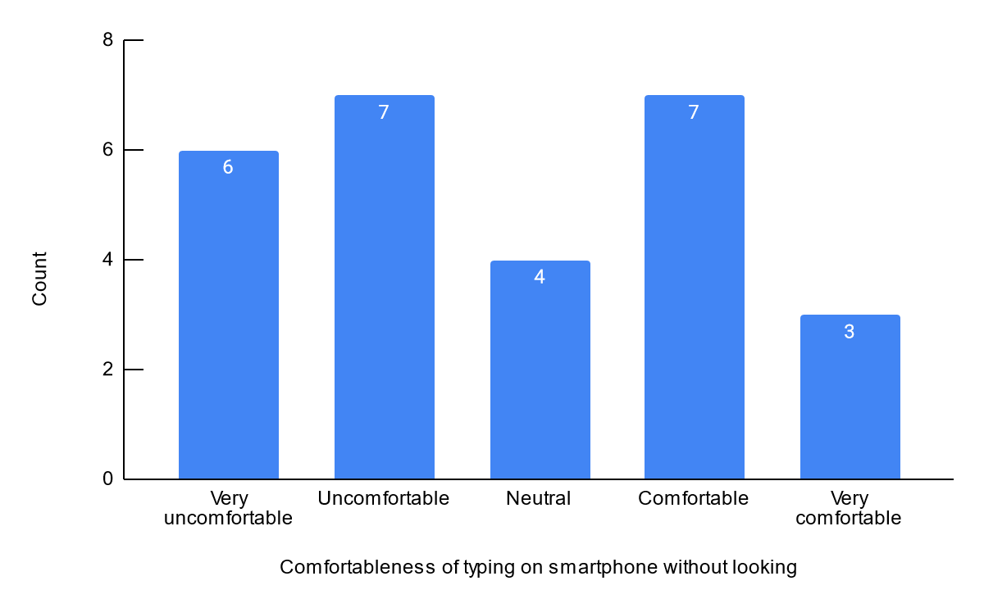

Figure 18. Count of different level of comfortableness experienced by participants when typing on their phone’s keyboard without looking

Question 19: What is your opinion on the autocomplete (predictive text) feature of your phone’s keyboard?

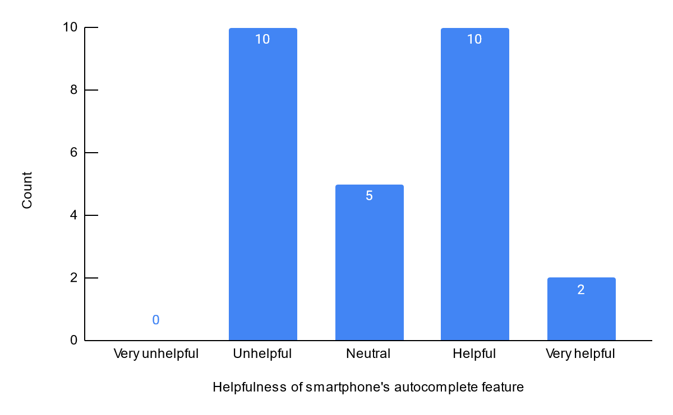

Figure 19. Count of different opinions expressed by participants on the helpfulness of smartphone’s autocomplete feature

Question 20: What is your opinion on customized shortcuts for typing? (e.g., type 'omw', turns into 'on my way')

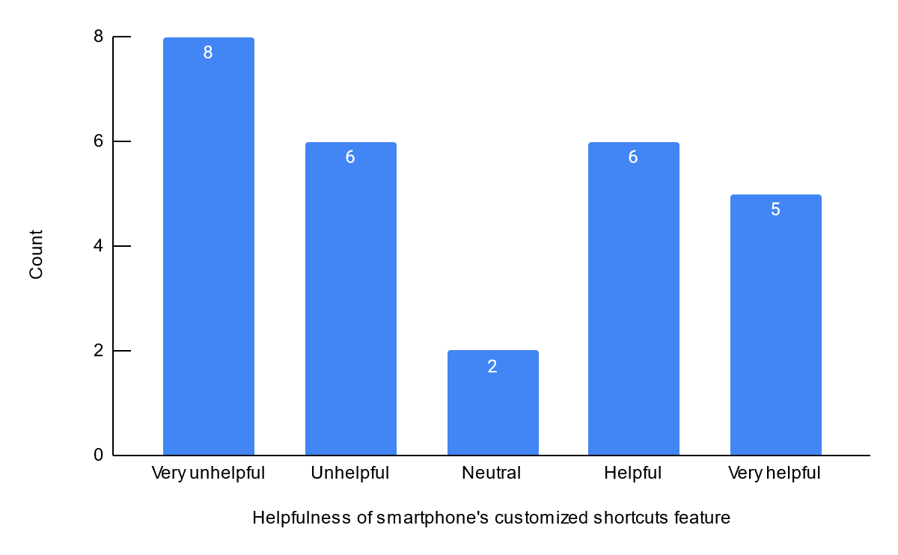

Figure 20. Count of different opinions expressed by participants on the helpfulness of smartphone’s customized keyboard shortcuts

Question 21: Have you ever tried other 3rd party keyboard apps on your phone?

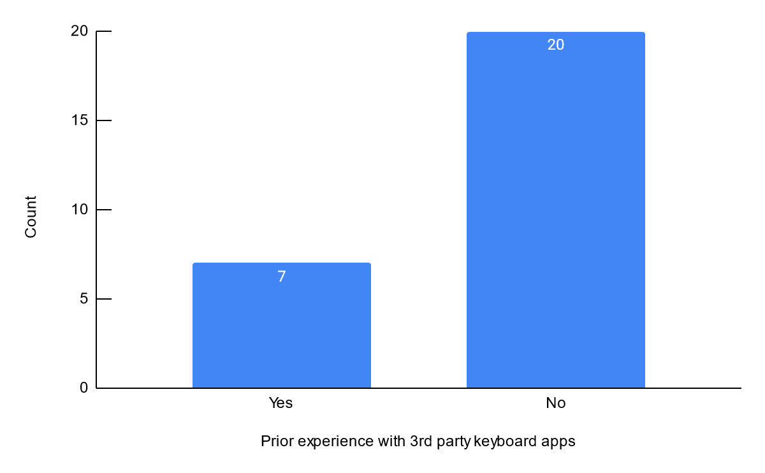

Figure 21. Count of whether participants have used third-party keyboards

Question 22: What is the level of difficulty of entering text on a smartphone compared to that of a computer?

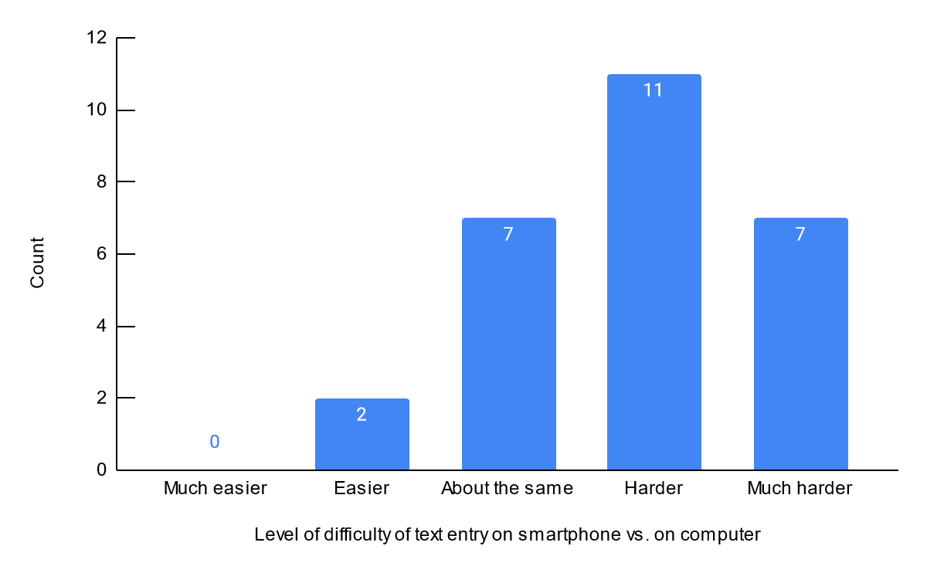

Figure 22. Count of different levels of difficulty of text entry experienced by participants on a smartphone compared to on a computer

Question 23: What are some other text entry methods that you have tried/used on your smartphone? Select all that apply.

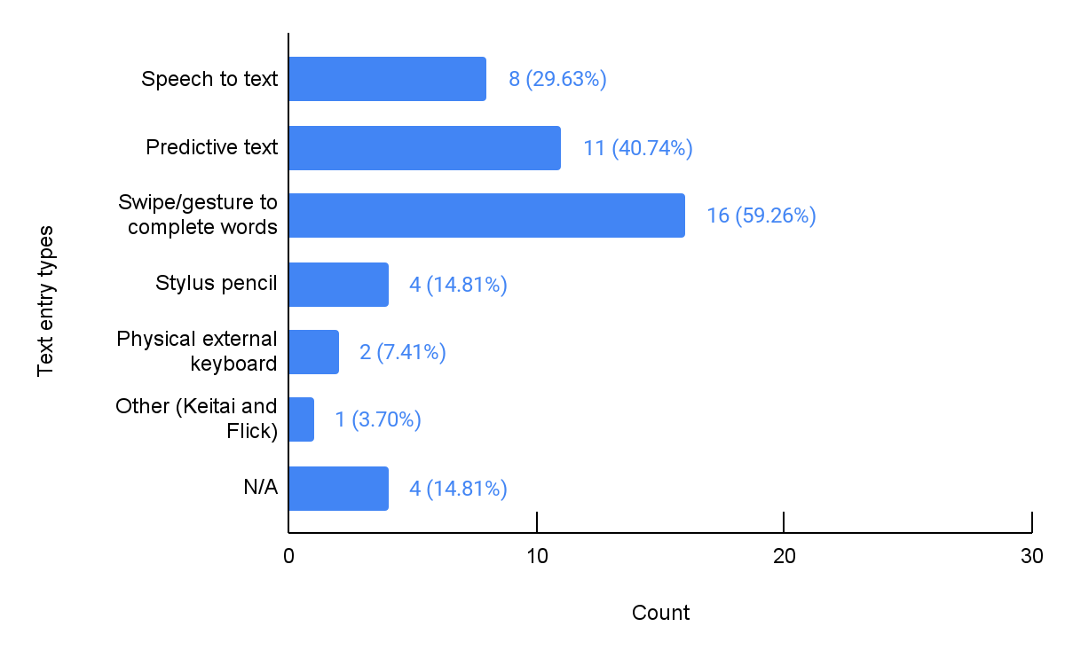

Figure 23. Count of different text entry types used by participants

**Questions 18 to 23 show miscellaneous findings from our survey results so as to potentially broaden or shift our focus.**

**Figure 18 shows how comfortable the participants are at touch typing, or typing without looking at the keyboard. The data showed that participants varied a lot in their ability of touch typing, with 10 participants (37.0%) being comfortable or very comfortable, 13 (48.1%) being uncomfortable or very uncomfortable, and 4 (14.8%) having neutral opinions.**

**We have also asked participants about their opinions on the autocomplete feature of their mobile device keyboard. Shown in Figure 19, almost half of participants find it to be at least helpful during text input. However, the larger half have neutral opinions at best, and find it unhelpful at worst.**

**From Figure 20 we can see that our participants are opinionated and divisive about customized shortcuts. A plurality (8 out of 26) of participants think it is very unhelpful. A total of 14 participants think it is unhelpful or very unhelpful. 11 participants think they are helpful or very helpful. Only 2 have neutral opinions.**

**We surveyed participants about whether they use a third-party keyboard on their phone. In figure 21, a majority of participants answered they have never used a third-party keyboard. Only a small portion answered they have used a third-party keyboard.**

**When asked about the difficulty of text entry on mobile phones compared to that of a computer with a physical keyboard, 18 participants think text entry on the phone is harder than on computer. Only 2 participants think it is somewhat easier. 7 participants think they are about the same in terms of difficulty. We can tell that a majority of people still think text entry on mobile devices is harder.**

**The participants were also surveyed on what other text entry input they have used. Most people have used speech-to-text, predictive text (autocomplete), and swipe input, with swipe-input (gesture) having the most users in our study.**

# Discussion

Does discussion contain a detailed interpretation of results? Does it reflect on how the results inform scoping of the focus? Does discussion state a new and/or narrower focus?

Summary of Findings

Before discussing the findings, it is important to note that we used a convenience sample for this survey, thus the results have low external validity. Consequently, all analysis and interpretations mentioned in Results and Discussion only apply to the specific sample of respondents of this survey. However, even without being able to generalize to a larger population, the results still do provide some initial insights into some existing issues with one-handed text entry on mobile devices.

Of the 27 participants who completed the survey, we found that one-handed text entry on smartphones is an existing interaction prevalent to users (as explained in Figure 3 and 4 in the Results section). Moreover, out of those who do type with one hand, users tend to find it less comfortable, harder, and slower to type with one hand compared to typing with both hands (as shown in Figure 6-8), implying that there are flaws in the current smartphone’s keyboard for the interaction of one-handed text entry. This supports our original focus on one-handed text entry on mobile devices.

In attempting to narrow down the focus by examining specific areas for improvement on the existing smartphone keyboard, we found that users tend to *make more typos* and *have a harder time to correc*

d that users find it more difficult to *switch between letters and numbers*, and also to switch the language of the keyboard with one hand than with both hands (as shown in Figure 14-16). These findings allow us to narrow the focus from “improving text entry on mobile devices with one hand”, to “improving the ability to fix typos, switch between numbers and letters, and switch languages on a smartphone keyboard with one hand”.

Furthermore, since the majority of participants use iPhone (Figure 2) and are right-handed (Figure 17), we decided to further narrow the focus to regarding just using the iPhone keyboard with the right hand. This may be beneficial to later stages in the UCD process since the iPhone has a uniform keyboard across all iPhone devices, unlike Android which has a wider variety of keyboards, thus limiting the potential confounding factors. Moreover, specifying the focus to be just the right hand also makes it easier for design since the usability of a one-handed keyboard likely depends on the hand which the user uses to interact.

Thus, from the survey results, we successfully showed the relevance of our focus and narrowed it down to “improving the iPhone keyboard to better support right-hand-only interaction, specifically on fixing typos, switching between letters/numbers, and switching languages.”

* The survey results showed the following takeaways about one-handed text entry
  + Results of questions 3 and 4 demonstrate that one-handed text entry on smartphones is an existing interaction prevalent to smartphone users.
  + Results of questions 6, 7, and 8 indicate that it is less comfortable, harder and slower to enter text with one hand on the smartphone compared to entering text with both hands, implying that there are flaws in the current smartphone’s keyboard for one-handed text entry.
  + Results of questions 9 and 10 show that users tend to make more typos and find them harder to correct when entering text with one hand compared to both hands.
    - However, there appears to be mixed feelings regarding the smartphone’s autocorrect feature, with the results being roughly evenly split on unhelpful, neutral, and helpful.
  + Results of question 12, 13 show that there are probably no issues with current layout and size of a smartphone’s keyboard, as a vast majority of participants have neutral opinions on them.
  + Results of question 14 show that it may be more difficult to switch between letters and numbers with one hand compared to both hands.
  + Results of question 15 and 16 also show that it is more difficult to switch languages on the keyboard with one hand compared to both hands.
* More general takeaways
  + The majority of participants use iPhone and are right-handed.

Narrower focus

* Improving the existing iPhone keyboard to better support right-hand-only text-entry, specifically on fixing typos, switching between letters/numbers, switching languages.

Limitations

* Convenience sample → low external validity. No generalizations of results can be made and all analysis and interpretations mentioned only apply to the sample of respondents of this survey. However, the results do provide some initial insights into some existing issues with one-handed text entry on smartphones.

# Appendix

Some of the survey options were distorted when exporting the survey to a pdf via Google Forms. Please send an email to the authors if you would like to request a copy of the survey in Google Forms.